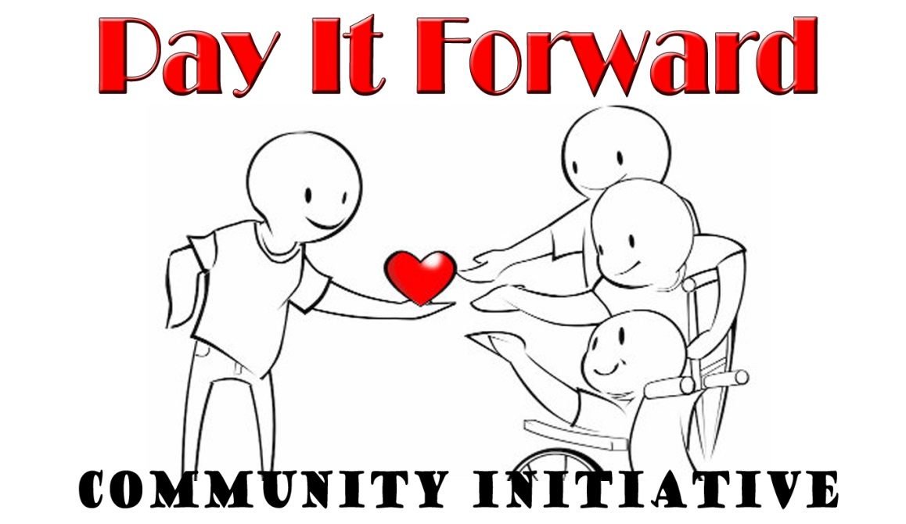

**Application**

If you are unsure what the question means or do not know the answer, please contact us for clarification. India Tuff, Executive Director, [onevpoffice@mail.com](mailto:maryannborman@aol.com) 888-962-6122

**About Your Organization**

|  |
| --- |
| Date:  Contact Name:  Legal Business/Organization Name, if any:  Is the organization name registered with your Secretary of State?  Address of Business/Organization:  Are all of your programs located at this address?  County:  Date Organization Founded: |
| Website:__________________________________ Mobile Phone:________________________________  Email:____________________________________ Telephone:__________________________________ |
| Seeking Funding for: ___________________________ Type of Program Services: _________________________ |
| **1.Tax Exempt/ Incorporation Info**   * Do you have 501(c)(3) federal IRS tax exempt status? If not, have you applied for it? When? _______________________________ or do you have a fiscal sponsor? * Provide the contact information for your fiscal sponsor, if any. * What is the date of incorporation listed on your 501(c)(3) approval letter? * Is it a provisional or temporary approval letter? __________________ * Are you incorporated in your state as a tax exempt organization? ___________ If so when? _______________   **2. Information (250 words or less per question)**   * Tell us your Mission Statement or purpose of your organization. * What do you want your organization as a whole, separate from this funded program to accomplish? * What other specific populations have you targeted to serve?   **3. Information About Your Specific Grant Request**.   * What will you produce or provide through this project? * How will this contribution specifically benefit the target population? * What is the goal of the project to be funded? Is there any specific timeline for the project? * How will you achieve this goal? What are the steps that need to be taken? * How will you know your project is on track? What are your interim goals? * How will this contribution specifically benefit others in the community (e.g., you, people to be employed, and customers to benefit from a unique product or service, other businesses that will get vendor work, neighbors who will enjoy a better environment? * What makes your project unique or innovative? * How will you advertise or promote the service to reach the target population? * What organizational funds will you invest? Do you have any community or business partners that will also invest in this project (if any)? What will they provide? * What are your estimated costs/expenditures for this project? Attach a budget with the following line items: * Amount, Details, Advertising/Promotional Materials, Equipment/Supplies, Transportation (if applicable). * What obstacles have you observed or experienced in the past with this type of program? * What are the strengths and weaknesses of your organization in relationship to implementing this contribution, and how you will work around them? |